Intro to Software Engineering
Iteration 1

Submitted By:

Burhan Ahmed 24i-3030

Faisal 24i-3032

Huzaifa Ali 24i-3114

Section:
SE-C

Date:
November 9, 2025



Department of Computer Science
National University of Computer and Emerging Sciences,
Islamabad, Pakistan

Sprint 1 - Backlog
1 | A1 | Admin Login.
2 | A2 | Approve Hostel Listings.
3 | A3 | Manage Ratings.
4 | H1 | Hostel Owner Login/Signup.
5 | H2 | Manage Hostel Listings.
6 | H3 | Answer User Questions.
7 | U1 | User Login/Signup.
8 | U2 | View Hostel Cards.
9 | U11 | View Hostel Details
10 | U12 | Review Hostel.
11 | U13 | Ask Question on Hostel Page.

1- Modules

- Admin Management Module:

Story id: A1 Story Title: Admin Login

User Story: Importance:

High
As a: Admin
I want: to login.
So that: I can manage the website.

Estimate:

3

Acceptance criteria:
- Search input accepts city, neighborhood, or postcode.
- Results show only listings matching the search term (partial matches allowed).
- Results display key info (name, short description, price, rating, distance text).
- Empty search shows helpful message and suggestions.

Technical Task:
- Implement login page (username, password).

- Implement backend credential verification.

- Implement session management and logout.

- Manual test: successful login, failed login, logout.

Story id: A2 Story Title: Approve Hostel Listings

User Story: Importance:

High
As a: Admin
I want: to review and approve new hostel listings
So that: only verified hostels are shown to users

Estimate:
4

Acceptance Criteria:
- Admin can view all newly submitted hostel listings.
- Each listing shows essential details (name, owner, location, rent, and contact).
- Admin can approve or reject listings.

Technical Task:
- Display list of new hostel listings

- Show details for each listing

- Add approve and reject buttons

- Test approved listings’ visibility to users

Story id: A3 Story Title: Manage Ratings

User Story: Importance:

High
Estimate:
3
As a: Admin
I want: to remove any rating
So that: ratings remain fair and trustworthy

Acceptance Criteria:
- Admin can view all hostel ratings.
- Each rating displays hostel name, user name, and rating value.
- Admin can delete unfair or fraudulent ratings

Technical Task:
- Design and implement ratings management page

- Display hostel name, user, and rating

- Add delete button for each rating

- Restrict page to admin access

- Verify functionality on deployment

- Hostel-Owner Management Module:

Story id: H1 Story Title: Hostel Owner Login/Signup

User Story: Importance:

As a: Hostel Owner
I want: log in or sign up
So that: I can manage my hostel listings.
High
Estimate:
3

Acceptance Criteria:
- A registration and login form is available for hostel owners.
- New owners can create an account with necessary details.
- Registered owners can log in securely.

Technical Task:
- Design and implement owner registration/login pages

- Test registration and login functionality

- Deploy and validate feature

Story id: H2 Story Title: Manage Hostel Listings

User Story: Importance:

As a: Hostel Owner
I want: to add, delete, or update hostels from my profile.
So that: I can keep my hostel information up to date.
High
Estimate:
5

Acceptance Criteria:
- Owner dashboard has a "My Listings" section.
- Owner can add a new listing with a form (name, location, rent, amenities, etc.).
- Owner can edit the details of any of their existing listings.
- Owner can delete (de-list) their hostel listings.

Technical Task:
- Create "My Listings" section in owner dashboard

- Implement add new listing form with validation

- Implement edit and delete functionality for existing listings

- Connect owner actions to public listing display

- Deploy and validate feature

Story id: H3 Story Title: Answer User Questions

User Story: Importance:

As a: Hostel Owner
I want: to answer questions on my hostel listings.
So that: I can engage with potential tenants,
Medium
Estimate:
3

Acceptance Criteria:
- Owners can see questions asked by users on each of their hostel pages.
- Owners can post public replies to these questions.
- The Q&A is displayed on the public hostel listing page.

Technical Task:
- Create interface for owners to view unanswered questions

- Implement answer submission functionality

- Display Q&A on public hostel page

- Deploy and validate feature

- User Management and Interaction Module:

Story id: U1 Story Title: User Login/Signup

User Story: Importance:

As a: User
I want: to log in or sign up.
So that: I can access personalized features like wishlist and reviews.
High
Estimate:
3

Acceptance Criteria:
- A registration and login form is available for general users.
- New users can create an account.
- Registered users can log in securely.
- Successful login provides access to personalized features.

Technical Task:
- Design and implement user registration/login pages

- Test registration and login functionality

- Deploy and validate feature

Story id: U2 Story Title: View Hostel Cards

User Story: Importance:

As a: User
I want: to view hostel cards.
So that: I can better visualize the hostel options.
High
Estimate:
1

Acceptance Criteria:
- The main search/browse page displays hostels as cards.
- Each card shows essential info: image, name, approximate rent, location, and average rating.

Technical Task:
- Design hostel card component

- Ensure responsive design

- Deploy and validate feature

Story id: U11 Story Title: View Hostel Details

User Story: Importance:

As a: User
I want: to view hostel details
So that: I can make an informed decision
High
Estimate:
3

Acceptance Criteria:
- Clicking on a hostel card navigates to a dedicated details page.
- The page displays all relevant information: images, full address, detailed amenities, rent, rules, owner FAQs, and user reviews.

Technical Task:
- Design hostel details page layout

- Populate all information sections (info, amenities, FAQs, reviews)

- Ensure responsive design

- Deploy and validate feature

Story id: U12 Story Title: Review Hostel

User Story: Importance:

As a: User
I want: to give a hostel a review.
So that: I can share my experience with others
High
Estimate:
3

Acceptance Criteria:
- A "Write a Review" form is available on the hostel details page for logged-in users.
- The form includes a rating (e.g., stars) and a text comment.
- Submitted reviews appear on the hostel's page after approval (if applicable).

Technical Task:
- Implement review form on hostel details page

- Create backend logic to save and retrieve reviews

- Display reviews on the hostel page

- Implement review validation (logged-in user)

- Deploy and validate feature

Story id: U13 Story Title: Ask Question on Hostel Page

User Story: Importance:

3
Estimate:
Medium
As a: User
I want: to ask questions on specific hostel page
So that: I can get more information before booking

Acceptance Criteria:
- A "Ask a Question" section is available on the hostel details page for logged-in users.
- Users can type and submit their questions.
- Submitted questions are visible on the page, awaiting an owner's response.

Technical Task:
- Implement question form on hostel details page

- Create backend logic to save and retrieve questions

- Display questions on the hostel page

- Deploy and validate feature

2- Functional Requirements

Admin User Stories:
User Story - A1:

As an admin, I want to log in so that I can manage the website.

Functional Requirements:

- The system shall provide a login page that is accessible to users with a role of 'Admin'.

- This system will ask an admin to log in using a registered email address and password.

- The system shall authenticate the provided credentials against stored admin accounts.

- On successful authentication, the system shall route the admin to the listing view.

- The system should return an error message in case of invalid credentials, such as "Invalid email or password".

- On successful login, the system will establish a secure session that keeps the admin logged in.

User Story - A2:

As an Admin, I want to be able to view and approve new listings of hostels so that only verified hostels are made available to users.

Functional Requirements:

- In the admin dashboard, there shall be a dedicated section, say "Pending Approvals", which lists all hostel listings submitted by owners with the status marked as "Pending".

- For each pending listing, key information that the system should display includes: Hostel Name, Owner, Location, Date Submitted, and a "View Details" button.

- Upon clicking "View Details," the complete hostel listing data as filled by the owner shall be displayed.

- The system shall provide the admin with two action buttons: "Approve" and "Reject".

- Upon clicking "Approve," the system shall change the hostel status to "Approved" and make it visible to all users on the platform.

- Upon clicking "Reject," the system asks for a reason for refusal from the admin, after which it automatically changes the status of the hostel to "Rejected." This listing will not be visible to users.

- The system will notify the owner through email or an in-system notification regarding the approval or rejection of their listing.

User Story – A3:

As an Admin, I want to remove any rating so that ratings remain fair and trustworthy.

Functional Requirements:

- In the admin dashboard, there will be a section—say, "Manage Reviews"—where all the ratings and reviews submitted by users can be viewed.

- The system should display each review along with its connected hostel, the user who made it, the rating, comment, and date.

- The system shall provide a "Delete" button for each review.

- Upon clicking "Delete," the system shall prompt the admin to confirm, for example: "Are you sure you want to delete this review?"

- Upon confirmation, the system will permanently delete the rating and review from the hostel's listing.

- The system should recalculate and update the average rating for the concerned hostel.

Hostel Owner User Stories:

User Story – H1:

As a hostel owner, I want to log in or sign up in order to manage hostel listings.

Functional Requirements:

- The system shall provide a login form for existing hostel owners.

- The system shall authenticate the owner using their email and password.

- It should redirect the owner to their personal dashboard once their credentials are verified.

- The system shall show an error message for invalid login attempts.

User Story – H2:

As a hostel owner, I want to add, delete, or update hostels from my profile so I can keep my hostel information up to date.

Functional Requirements:

- The system shall provide an "Add New Hostel" button from the owner dashboard.

- Upon clicking, the system shall display a form to input hostel details, including: Hostel Name, Address, Location/City, Gender (Male/Female/Mixed), Rent, Amenities (checkboxes for WiFi, Laundry, AC, etc.), Description, and Photos.

- Upon submission, the system shall save the listing with a status of "Pending" until approved by an admin.

- The owner's dashboard will show all their hostels - both "Pending" and "Approved".

- The system shall provide an "Edit" button for each hostel.

- Clicking on "Edit" should open a pre-populated form with the existing hostel data, with the ability for an owner to modify any field.

- Whenever you save your changes, your listing, once approved, may revert to "pending" for re-approval if critical fields have been changed, such as name or location.

- The system will provide a "Delete" button for every listed hostel.

- Upon clicking "Delete," the system will ask for confirmation.

- Once confirmed, the system should permanently delete the hostel listing from the platform.

User Story – H3:

As a Hostel Owner, I want to answer questions on my hostel listings so that I can engage with potential tenants.

Functional Requirements:

- It shall also provide in the owner's dashboard a "Questions" section, enumerating the unanswered questions by users in each of their hostels.

- Each entry should show the user's question, the date it was asked, and the relevant hostel name.

- The system shall provide a text input field for the owner to type their answer.

- The system shall provide a "Post Answer" or "Reply" button.

- Upon posting, the answer shall be shown directly under the question on the public hostel details page.

Tenant User Stories:

User Story – U1:

As a user, I would like to log in or sign up in order to access personalized features such as
'Wishlist' and 'Reviews'.

Functional Requirements:

- The system shall have a login form for registered users.

- The system should authenticate the user by using their email address and password.

- If the user has successfully authenticated, the system will redirect him/her to either the home page or his/her previous page, now in logged-in state.

- System shall show an error message for invalid credentials.

User Story – U2:

As a User, I want to view hostel cards so that I can better visualize the hostel options.

Functional Requirements:

- Available hostels shall be displayed in card-based layout on the system's main page.

- Every hostel card should have the following information: Hostel name, location, monthly rent, average rating as stars and/or a number, and a thumbnail image.

- Cards shall be arranged in the form of a responsive grid layout.

- Clicking on a hostel card shall navigate the user to the detailed view for that hostel

User Story – U11:

As a User, I want to view hostel details so I can make an informed decision.

Functional Requirements:

- The system should have a dedicated page for every hostel.

- This page shall display all relevant details, including:

- Name of the hostel, full address, and location on a map.

- Monthly rent and security deposit details.

- Listed amenities

- Detailed Description.

- Average Rating and all individual user reviews - U12.

- All user questions and owner answers.

User Story – U12:

As a user, I want to review a hostel so that I can share my experience with others.

Functional Requirements:

- The system shall display a section called "Write a Review" on the hostel details page for logged-in users.

- The feedback form will force a user to choose a star rating, such as selecting 1 to 5 stars.

- The form shall include a text area for a written comment, which is optional.

- The system shall provide a "Submit Review" button.

- Once submitted, the system should store the review and connect it with the user and the hostel.

- The system shall update the average rating for the hostel immediately and show the new review in the list of reviews.

- The system should allow a user to submit only one review per hostel.

User Story:

As a User, I want to ask questions on a specific hostel page so that I can get more information before booking.

Functional Requirements:

- On a hostel's detail page, the system shall display an "Ask a Question" section.

- This section will house a text entry field and a "Post Question" button.

- The system should require that the user be logged in to display the input field for the question.

- Upon clicking "Post Question," the system shall save the question and display it in a "Questions and Answers" section on the same page.

3- Prototyping

- Development
Link:
https://github.com/burhan-15/Hostel-Facilitator

Repository Snap-Shoot:

- Trello Board
1.Snapshots:

Snapshot – 1:
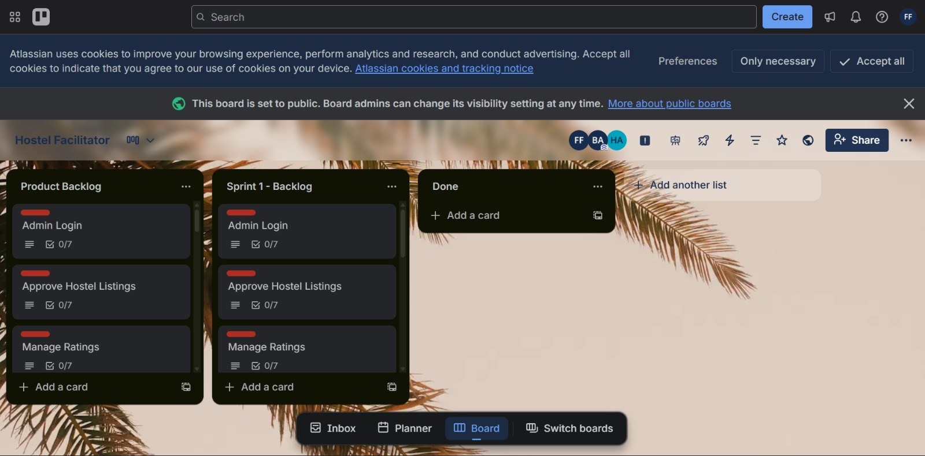

Snapshot – 2:
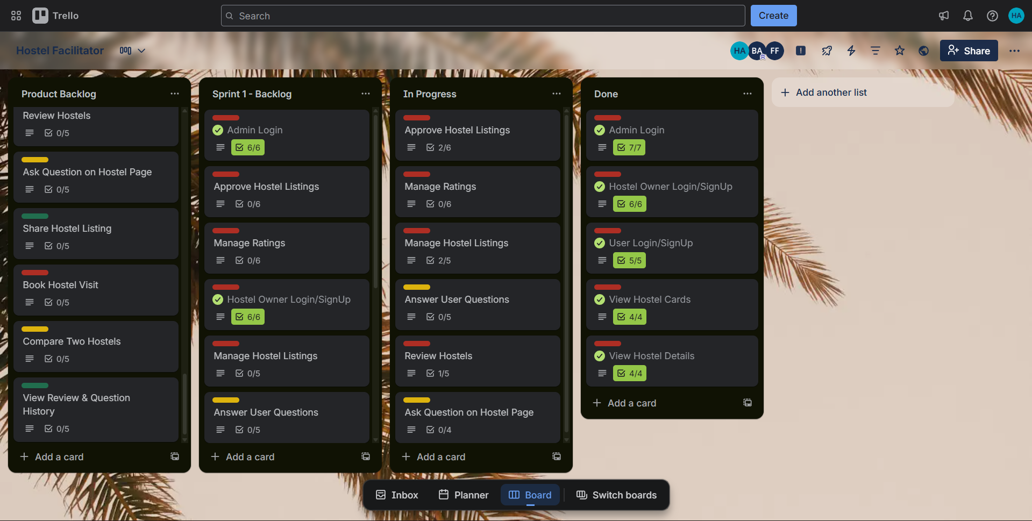

Snapshot – 3:

Snapshot – 4:

2.Sprint Burn-down chart:

